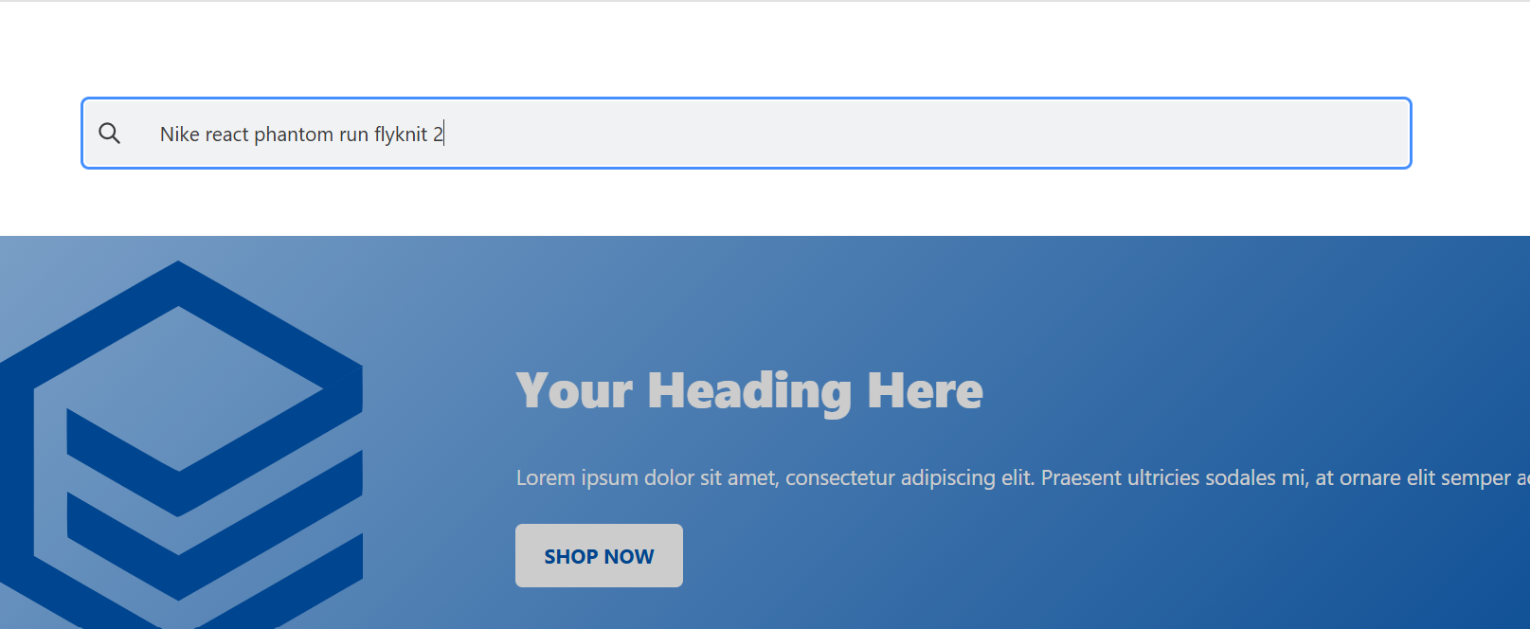

Test id 4 : suggestions is not showing